# Abstract

In this project, a Restaurant Reservation App needs to be developed. Before actually writing the project, a background research and critical reviews needs to be looked at in other similar systems that are out there and review them and talk about how it all relates to my project. Literature review aims to cover these areas in general and gives a starting point in developing my app.

# Introduction

# Project motivation

Being a computer science student and learning different programming languages throughout the previous years, out of all the other languages Java has always been one of my favourite language. My interest towards java expanded when I found out that most of the apps and games are developed using java. As developing apps and games is a subject that I am interested making my career in, this project will give me an opportunity to explore the world of android apps and expand my knowledge more.

Moreover, my motivation for developing this android application came from my family who are involved in restaurant business sector. Whenever I decide to go and help the family run restaurant in busy times, there always seem to be some sort of problem with double bookings and not enough table for ‘walk in’ customers. Even though the restaurant could only sit 60 customers at once, you can’t really predict when the customers will leave the table for another booking. Having a little knowledge of how the restaurant works, I believe that every owner of restaurant would want their business to rise economically, and in every restaurant, the more customer means more business. So, I decided to develop an application which could ease any type of restaurants booking system. This application wouldn’t allow any double bookings to occur which will satisfy the owners as well as satisfying the customers as they could choose their own favourite table of their choice. This could also help the business growth both economically and widely recognisable.

# Aims and objective.

In this Project, I will be developing an android application which will be a restaurant reservation app. Before getting into the development of the application, firstly I will have to do my interim report which will be literature review and functional requirements for the project that I will be developing. The core objective for interim report will mainly focus on the literature review and functional requirements which will contain the following:

* Researching the History of the online reservation, how it started and how it has been successfully developing throughout the years.
* It will also examine other similar applications, which uses similar concepts and services.
* The review will also investigate the problem areas which can or might occur in the project, and talk about what action could be taken to prevent those problems.
* Functional requirements for Admin application.
* Functional requirements for Users application.

As an appendix, the report will also contain all the work which has been undertaken to the date which are as follow:

* Project contract
* BSc checklists, Global checklist, ethical issue form and project plan (Gantt chart).
* Progress periodic report.

# History of online table Reservation

The History of online reservation starts from the late 90s, and throughout the years it has been growing rapidly in varieties of platforms such as website reservation, mobile app reservation etc. According to the ‘**Kimes, S.E.(2009).How restaurant customers view online reservations’** electronic article The idea of online reservation started from one of the largest online restaurant reservation provider called OpenTable.com. Later throughout the years the idea became very effective to restaurants which led to a massive increase of 1 millions of customers just under 3 years, leading it to exceed more than 70 million customers by 2008. OpenTable now seats 3 million diners per month. At present time OpenTable is now known as the World’s leading online restaurant reservation provider, seating 23 million diners per month across more than 43000 restaurants over the world.

# Existing

Restaurants nowadays are commonly taking online reservations for their clients, specially fine dine dining. Many restaurant owner believes that this service has become an integral part of the service for now to operate the Restaurant businesses as it comes with multiple of benefits.

### Telephone Reservation

Telephone reservations are very commonly used in any types of restaurants. Telephone reservation has many benefits for customers and the restaurant itself as reserving table through the phone can allow customers to have personal connection with the restaurant owners. however not bookings through phone calls aren’t always the best ideas as it will also have a lot of drawbacks. Some of the disadvantages of telephone reservations are as follow:

* It may be difficult to arrange the needs of the customers’ demands in busy times.
* It is only operated in opening times of the restaurants.
* There might be cause of double bookings and other human errors whilst taking the booking.

Some of the problems that has being occurring and majorities of restaurant are commonly facing are such as, restaurants staffs not being able to manage and fit in walk in’s (Non-reserved) customers in busy peak times. Whereas in the off-peak times the restaurants tends to become very quiet.

# Online Reservation

Online reservation is an another existing platform for restaurant to offer their customers to make the table bookings. Since the online reservation started, it has gained many benefits for both restaurants and customers. Some of the benefits gained by using online reservation for restaurant are as follows:

* Improve on service quality.
* Could avoid mistakes such as e.g. double bookings or any other human errors.
* Could improve on volume and revenue of the business by marketing and targeting more customers.

Additionally ‘ **The power of restaurant reservation systems, article by Elly Earls-The Caterer’** illustrates with the research showing that the 64% of restaurant searches result in reservation made through online are being made within an hour meaning that the users are reserving tables on the go. This makes a reservation through an app a very convenient way to book a table if you are outside.

# Choice of Hardware and Software

## Software interface

The application will only run on the android operating system, specially on the version 4.4 KitKat. The reason I chose android studio as my IDE is because I think android studio is one of the most effective software for developing any sort of android applications. As android been an open source platform for everyone and as per now a day’s androids operating system are been widely recognised across the world since they are used in most of the platforms and devices such as mobile phones, tablet, TV and computers etc.

# Location and Map service

Google maps is another external API which I am considering to include on my app. Using Google maps API, it will allow the application to locate the nearest restaurants based on the google map data.

# Hardware

Minimum Hardware requirement for android studio:

* SSD
* 8 GB of RAM
* Core i5

# Choice of Programming Language

Android Studio uses many programming languages such as Java, C#, Kotlin etc. Java being the most popular and first option to develop android apps, it is also an official programming language for android development.

Throughout my previous experience with java taught me that Java has most of the support for games and apps on play store and it is supported from Google. Java has been a one of the oldest programming language which was officially released back in 1995, meaning that it is now used for wide range of programming languages.

# Firebase

To store the user’s data’s, images and other information, the back- end system that I would be using will is firebase, which is very smoother and faster for debugging and rolling out increase level in the application. Firebase uses the real-time database where data is mostly stored as JSON and it synchronized continuously with each associated client. As my application with be built through firebase, there will be no need for me to make my own database or any sort of APIs, as it handles all the components with simply creating backend for app. There are many benefits with using firebase such as:

* + - Real Time Database provides real time application database, which will let the developer synchronize data and store it in the firebase cloud.
    - App notification which will be desirable for letting the users know that they have some information to check.
    - Supports authentication using email id and password.

# Similar applications

There are many different applications out there which allows users to book the restaurant just by tapping on the phone screen, and then the users are allocated in a random table. However, there aren’t many application which gives users an opportunity to look at the table image and pick the table before going ahead with their booking, which makes this app unique than others.

As I am expecting my app to display the inside layout of the restaurant tables so that the users could choose a table of their choice depending on where they prefer to seat, I surveyed similar applications that are out there which contains similar type of features.

After surveying some other similar applications, first similar application that I came across with was cineworld app which also uses similar feature such as letting the users choose the seats they prefer.

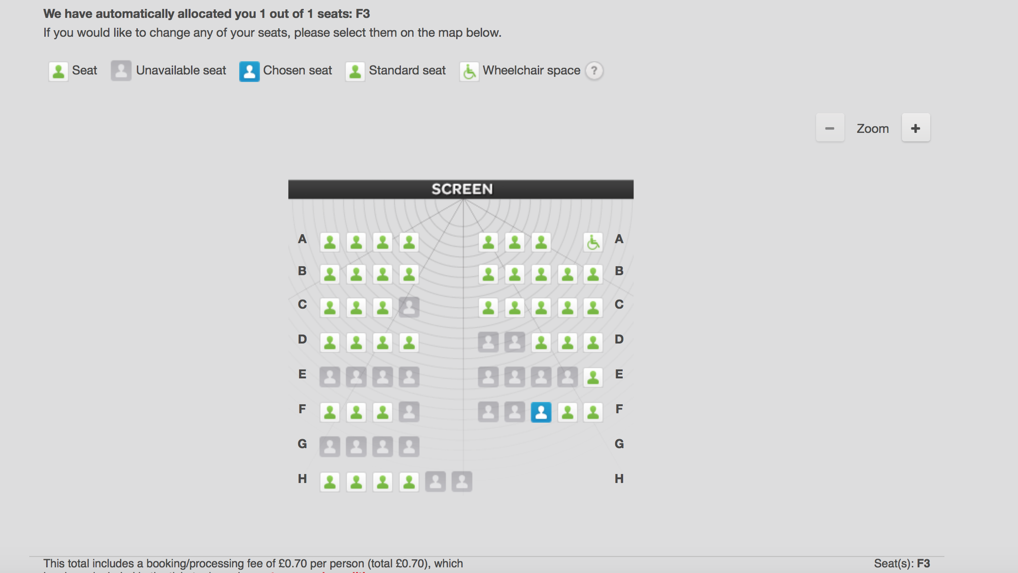

Figure 1 screenshot of reserving the seat for cinema.

As we can see on Figure 1, it illustrates the seats planning of movie screen for cineworld. Once the user chooses number of seats they want to book, the system automatically allocates the seat as a ‘chosen seat’ and it highlights the seats as blue, available seats as green and unavailable seats as grey, so that other users can’t book the same seat which has already been booked. Even though the feature seems to be very basic in terms of graphic wise, I think it will satisfy enough the users knowing that they have reserved the seat they wanted.

For my restaurant app, I will be using features which will be very much alike the cineworld app. However, I will consider on making sure that the features are more appealing to the users. I will be make sure that once user touches the table on their devices, a small icon should display on the screen showing the picture of the table that user chose.

Secondly, another application that I came across which is fairly like the application that I will be developing which is ResDiary. ResDiary offers online reservation portal, [www.resdiary.com](http://www.resdiary.com) and they also provide application which can be installed on your devices. ResDiary is a very convenient app for users, which lets diners instantly book nearby restaurants on the go.

The idea of instantly reserving the restaurant depending on their location is a very efficient idea, as it will give the users an option for different types of cuisines.

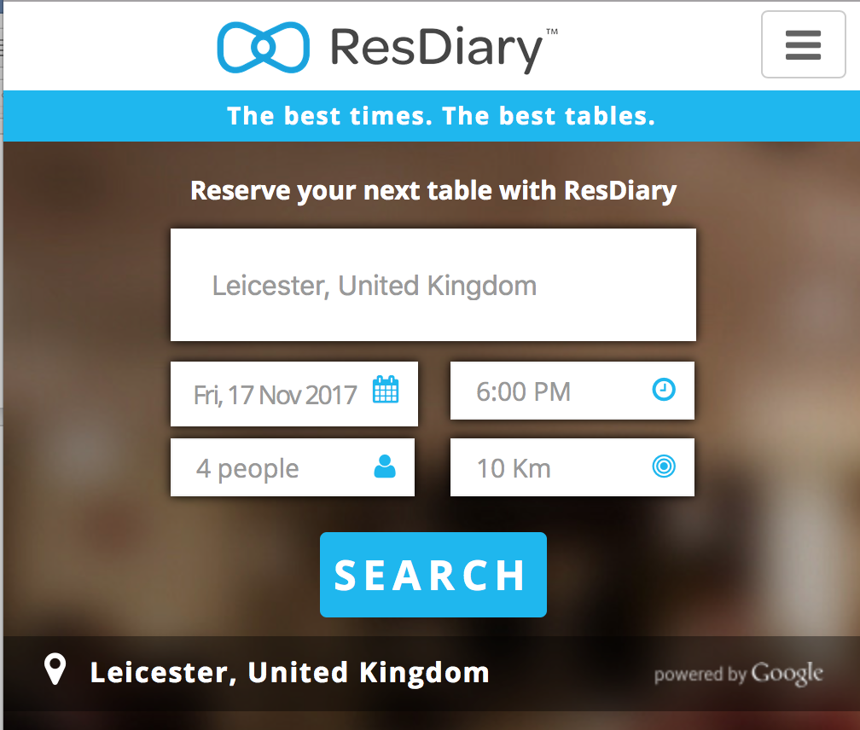

Figure Screenshot of ResDiary application.

### Targeted Users

# Android users

The application will be targeted for all type of users who owns an android phone. According to the ‘Mike Conyers, founder for online reservation system provider of ResDiary’ says that over 60% of UK adults now own mobile phones and more than 95 % of users use their smartphones to reserve their restaurant.

# Restaurant Owners

As the application will be a third-party service which will be provided for the restaurant, the main targeted user for the application will be restaurant owners, as they will have to make an agreement on whether they would want their restaurant to be shown on the application.

# Conclusion

Lastly overall to summaries my review, after surveying similar applications and looking at the issues with current applications, I think developing my app will be beneficial for both restaurant and the customers. The core objective of the application is to make the way of reserving a table lot easier for the restaurant customers. At the end of the day not all the customers are happy with where they are seated at the restaurant, some prefer somewhere quite in the corner or some prefer where the environment is lively and crowded. I think this application will really fulfill to choose the customers desired tables, as it will allow the them to pick the table, look at the picture of the table and then reserve it.

I think this procedure will also allow the restaurant to manage their bookings quite successfully, as the system will automatically arrange the bookings so there will be no issues with double bookings or any other errors which are normally caused by staffs if they took the reservation through telephone. Another benefit for the restaurant with the application is that they won’t have to set up a table planner manually every time for each booking made through other platforms like website booking or phone call. Since you can input those bookings in the app which would then update the user’s app saying that the table is unavailable.

https://booking.cineworld.co.uk/booking/8016/115458/7660d070ca2011e7952eed24edc1aab0/seats. (2017). [image]. (Figure 1)

<https://www.resdiary.com/Search?searchText=Leicester,%20United%20Kingdom&latitude=52.6368778&longitude=-1.1397592&page=1&searchDistance=10&visitDate=2017-11-17&visitTime=18:00&covers=4> figure 2

<https://www.thecaterer.com/articles/494589/the-power-of-restaurant-reservation-systems>

<http://homepages.herts.ac.uk/~comtmgr/project.pdf>

<https://www.webstaurantstore.com/article/123/restaurant-reservations-system.html>

<http://scholarship.sha.cornell.edu/cgi/viewcontent.cgi?article=1828&context=articles>